**Git**

* Git is a Distributed Version Control System (DVCS).
* Git manages **commits**, which are collections of changes to the codebase.

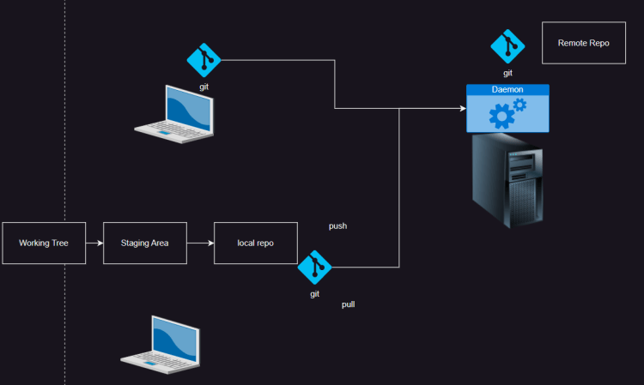

**GitHub**

* GitHub provides **Git hosting services** and is the largest repository for open-source codebases.
* GitHub also includes **Projects**, a feature for managing releases, issues, and more.

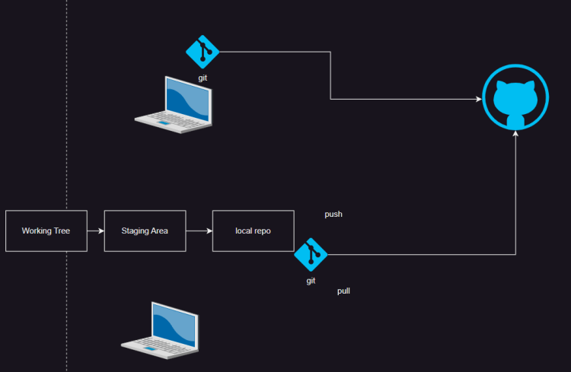

**Timeline**

* **2008**: GitHub launched as a platform for hosting and collaborating on Git repositories.
* **2011**:
  + GitHub Pages
  + Organizations
* **2012**:
  + Pull Request Enhancements
  + GitHub Enterprise
* **2013**:
  + Gists
  + Webhooks and Integrations
* **2014**:
  + GitHub Desktop
* **2016**:
  + Git Large File Storage (LFS)
  + Project Management Tools
* **2017**:
  + Code Review Improvements
  + Dependency Graph
* **2018**:
  + Security Alerts
  + GitHub acquired by Microsoft
* **2019**:
  + GitHub Actions became Generally Available, enhancing CI/CD and automation
  + GitHub Sponsors
* **2020**:
  + Discussions
  + Advanced Security
  + Free Private Repositories
* **2021**:
  + Copilot (Preview)
  + Codespaces
* **2022**:
  + Copilot (General Availability)
  + Private Vulnerability Reporting
* **2023**:
  + GitHub Security Advisories
  + Dependency Review
  + Mobile experience improvements

**GitHub Actions**

* GitHub Actions is an end-to-end GitHub-centric **Software Development Lifecycle (SDLC)** automation framework.
* It removes the need for external CI/CD tools like Jenkins or Travis CI.
* With GitHub Actions, CI/CD pipelines can be executed based on:
  + Pull requests
  + Push events
  + Scheduled times
* Workflows are stored alongside your code in the GitHub repository.

GitHub Actions provides:

**Starter Workflows**:

* + Help users set up common workflows.
  + Categories include:
    - Deployment
    - Security
    - Continuous Integration (CI)
    - Automation
    - Pages

**Actions Marketplace**:

* + Offers a library of reusable actions.